Paper Title (Number 10, Times New Roman, bold)
Subtitle as needed (paper subtitle)
First Authors Name,
First name Last name1, 2, *, First name Last name3, First name Last name1, First name Last name3
1Affiliation 1 (Affiliation, University ,City, post code, Country)
2Affiliation 2 (Affiliation, University ,City, post code, Country)
3Affiliation 3 (Affiliation, University ,City, post code, Country)
*Corresponding author: XXX, E-mail: xxxxxxxx
Other authors’ email:xxxxxxxx

Abstract: Please enter the abstract here. Please enter the abstract here. Please enter the abstract here. Please enter the abstract here. Please enter the abstract here. Please enter the abstract here. Please enter the abstract here. Please enter the abstract here. Please enter the abstract here. Please enter the abstract here. Please enter the abstract here. Please enter the abstract here.
Keywords: Keyword 1; Keyword 2; Keyword 3; Keyword 4; Keyword 5
- INTRODUCTION (Heading 1)
This template, modified in MS Word 2003 and saved as “Word 97-2003 & 6.0/95 – RTF” for the PC, provides authors with most of the formatting specifications needed for preparing electronic versions of their papers. All standard paper components have been specified for three reasons: (1) ease of use when formatting individual papers, (2) automatic compliance to electronic requirements that facilitate the concurrent or later production of electronic products, and (3) conformity of style throughout a conference proceedings. Margins, column widths, line spacing, and type styles are built-in; examples of the type styles are provided throughout this document and are identified in italic type, within parentheses, following the example. Some components, such as multi-leveled equations, graphics, and tables are not prescribed, although the various table text styles are provided. The formatter will need to create these components, incorporating the applicable criteria that follow.
- EXPERIMENT (FIRST LEVEL HEADING)
2.1. Experimental Subjects (Second Level Heading)
First, confirm that you have the correct template for your paper size. The template is used to format your paper and style the text. The template is used to format your paper and style the text. The template is used to format your paper and style the text. The template is used to format your paper and style the text. The template is used to format your paper and style the text. The template is used to format your paper and style the text. The template is used to format your paper and style the text.
2.1.1 Maintaining the Integrity of the Specifications (Third level heading)
The template is used to format your paper and style the text. The template is used to format your paper and style the text. The template is used to format your paper and style the text. The template is used to format your paper and style the text. The template is used to format your paper and style the text. The template is used to format your paper and style the text. The template is used to format your paper and style the text. The template is used to format your paper and style the text. The template is used to format your paper and style the text. The template is used to format your paper and style the text. The template is used to format your paper and style the text.
- PREPARE YOUR PAPER BEFORE STYLING
Before you begin to format your paper, first write and save the content as a separate text file. Keep your text and graphic files separate until after the text has been formatted and styled. Do not use hard tabs, and limit use of hard returns to only one return at the end of a paragraph. Do not add any kind of pagination anywhere in the paper. Do not number text heads-the template will do that for you.
Finally, complete content and organizational editing before formatting. Please take note of the following items when proofreading spelling and grammar:
3.1 Abbreviations and Acronyms
Define abbreviations and acronyms the first time they are used in the text, even after they have been defined in the abstract. Abbreviations such as SI, MKS, CGS, sc, dc, and rms do not have to be defined. Do not use abbreviations in the title or heads unless they are unavoidable.
3.2 Equations
The equations are an exception to the prescribed specifications of this template. You will need to determine whether or not your equation should be typed using either the Times New Roman or the Symbol font (please no other font). To create multileveled equations, it may be necessary to treat the equation as a graphic and insert it into the text after your paper is styled.
(1)
3.3 Figures and Tables

Positioning Figures and Tables: Place figures and tables at the top and bottom of columns. Avoid placing them in the middle of columns. Large figures and tables may span across both columns. Figure captions should be below the figures; table heads should appear above the tables. Insert figures and tables after they are cited in the text. Use the abbreviation “Fig. 1”, even at the beginning of a sentence.
Table 1, table tittle
Table Head | Table Column Head
Table Head | Table column subhead | Subhead | Subhead
copy | More table copyª
a. Sample of a Table footnote. (Table footnote)

- Example of a figure caption. (figure caption)
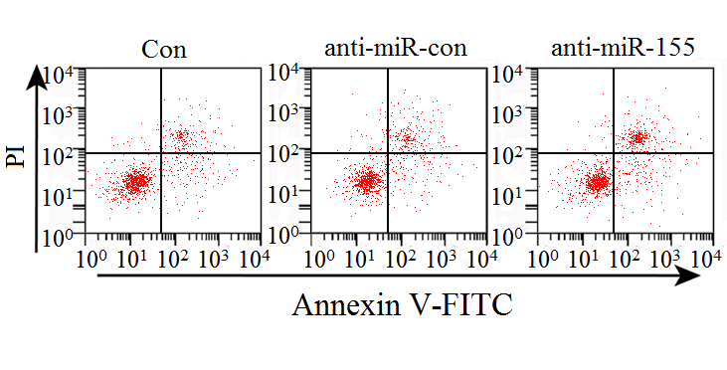
- Conclusions
This paragraph is a conclusion.This paragraph is a conclusion. This paragraph is a conclusion. This paragraph is a conclusion. This paragraph is a conclusion. This paragraph is a conclusion. This paragraph is a conclusion. This paragraph is a conclusion. This paragraph is a conclusion. This paragraph is a conclusion.

Acknowledgment
The preferred spelling of the word “acknowledgment” in America is without an “e” after the “g”. Avoid the stilted expression, “One of us (R. B. G.) thanks . . .” Instead, try “R. B. G. thanks”. Put sponsor acknowledgments in the unnum-bered footnote on the first page.
References
The template will number citations consecutively within brackets [1]. The sentence punctuation follows the bracket [2]. Refer simply to the reference number, as in [3]—do not use “Ref. [3]” or “reference [3]” except at the beginning of a sentence: “Reference [3] was the first . . .”
Number footnotes separately in superscripts. Place the actual footnote at the bottom of the column in which it was cited. Do not put footnotes in the reference list. Use letters for table footnotes.
Unless there are six authors or more give all authors' names; do not use “et al.”. Papers that have not been published, even if they have been submitted for publication, should be cited as “unpublished” [4]. Papers that have been accepted for publication should be cited as “in press” [5]. Capitalize only the first word in a paper title, except for proper nouns and element symbols.
For papers published in translation journals, please give the English citation first, followed by the original foreign-language citation [6].
- Avey, J., Wu, K., & Holley, E. (2014). The influence of abusive supervision and job embeddedness on citizenship and deviance. Journal of Business Ethics, 129(3), 721–731.
- Brykman, K. M., & King, D. D. (2021). A resource model of team resilience capacity and learning. Group & Organization Management, 46(4), 737–772.
- Campero, S. (2021). Hiring and intra-occupational gender segregation in software engineering. American Sociological Review, 86(1), 60–92.
- Chandrasekaran, A., & Mishra, A. (2012). Task design, team context, and psychological safety: An empirical analysis of R&D projects in high technology organizations. Production and Operations Management, 21(6), 977–996.
- Gong, Y., Kim, T. Y., Lee, D. R., & Zhu, J. (2013). A multilevel model of team goal orientation, information exchange, and creativity. Academy of Management Journal, 56(3), 827–851.
- Awtrey, E., Thornley, N., Dannals, J. E., Barnes, C. M., & Uhlmann, E. L. (2021). Distribution neglect in performance evaluations. Organizational Behavior and Human Decision Processes, 165, 213–227.

